ACADEMIC SUPPORT PROGRAM FOR STUDENT-ATHLETES

The mission of the Academic Support Program for Student-Athletes (ASPSA) is:
- to provide a comprehensive support system that affords Johnson student-athletes equitable opportunity to pursue academic, personal, and professional development resources;
- to complement the University’s goal of developing lifelong learners;
- to support the recruitment, retention and graduation of Johnson student-athletes.

Overview: There are three (3) parts to the academic support services provided by the athletic department:

1. Learning Objectives – Students will be informed of and engage with the following skill workshops by the end of their career at NVU-Johnson:
  - FIRST YEAR:
    - First semester: Time Management – Understand what it takes to effectively manage time between studies, athletics, and social life.
    - Second semester: Campus Resources Available – Educational Technology, Academic Support Services

  - SECOND YEAR:
    - First semester: Experiential Learning: What is available by way of service learning and internships and how can you prepare for them?
    - Second semester: Resume Building: Learn how to take practical work experience and turn it into a strong resume.

  - THIRD YEAR:
    - First semester: Multiple Intelligences: Understand what it means to know your own multiple intelligences and how to leverage them.
    - Second semester: Conflict Resolution: What is conflict resolution and how does that play out in academic, athletic and/or professional settings

  - FOURTH YEAR:
    - First semester: Life after NVU-Johnson: Deciding whether you want to pursue graduate work or a career right out of college can be daunting. Take advantage of our on-campus resources to figure out what is best for you.
    - Second semester: Networking 101: Learn how to establish a network and keep your network working for you.

2. Outcome Summations

a. PROGESS REPORTS
i. Athletics will administer progress reports 1-2 times per semester. Coaches will received the progress reports via email and in their college mailbox from the Athletic staff member responsible for Student-Athlete Development and are asked to distribute the progress reports to their team(s). If a coach is unable to make it to campus to distribute to their teams then the AD for SA-Development will assist with the distribution.

Progress reports will have a due date and are to be returned to either the athletes coach or to the AD for SA-Development.
Example of Progress Report:
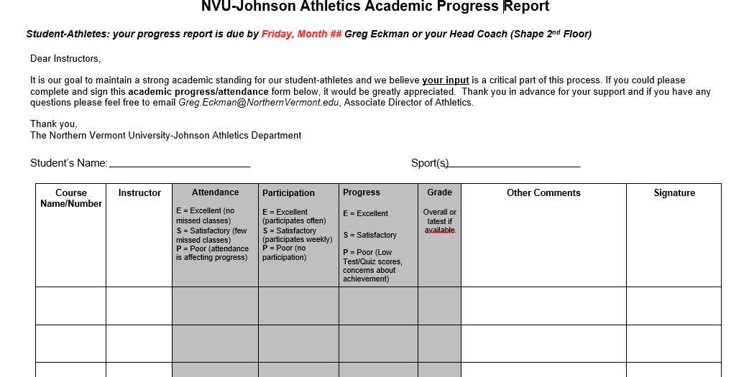

b. ONLINE GRADE BOOKS
i. NVU utilizes an online Grade Book system. Over the years we have seen greater adoption by the NVU faculty in reporting grades in real time using this system. This is a great tool for our Student-Athletes. Coaches do not have access to this system.

c. INDIVIDUAL & TEAM GPA’s
i. At the culmination of each semester the NVU Registrars offices will provide the NVU-Johnson athletic department AD with the individual GPA’s of each student-athlete, which will then be shared with their respective coaches.
ii. The AD for SA-Development with review the individual and team GPA’s with the departments FAR (Faculty Advisory Representation) to provide data analysis on the individual and team GPA’s.

3. Attentiveness to Student-Athlete

a. ACADEMIC MEETINGS
i. On campus coaches – Are expected to hold regular meetings in-season and out-of-season regarding individual and team academics performance, support and outcomes.
ii. Off campus coaches - Will partner with AD for SA-Development / Academic Support / Advising Office to conduct the regular academic meetings, providing the same level of support as on campus coaches.

b. STUDENT CONCERNS MEETING (name change coming for 20/21)
i. NVU-Johnson has a standing committee who meetings weekly to review all students on campus and works to identify students who may need support or assistance on a wide range of topics. At these meeting students are either brought forward through and online submission form found on the Portal or via and email to the athletic departments Assistant or Association Athletic Director(s). Students are brought forward by anyone from faculty to other students who may be concerned about a student’s wellbeing. Once a student is identified the committee comes up with who is the correct person to speak with and assist the student if need be.

c. ACADEMIC ALERTS
i. Faculty will provide academic alerts once a semester on students that are not meeting attendance, assignment or have low test scores.

d. NVU WELLNESS CENTER
i. NVU-Johnson has an on-campus Wellness Center for students located on the back side of Senator’s residence halls and is staffed by FT, PT and student interns. The Wellness Center has walk-in options or students are able to set up regular meetings.
ii.The Wellness Center has partnered with a national originations, JED, who provides analysis of on campus support service, provides guidance and strategic planning in partnership with campus wellness center for the mental wellbeing of our students.

